Skin Disease and Cancer detection

**Team number: 32**

**Hidesh Balaji C U [CB.EN.U4CSE21320]**

**Sivaraj Kumar S[CB.EN.U4CSE21457]**

**Base paper of the project:**

1. A machine learning-based, decision support, mobile phone application for diagnosis of common dermatological diseases R. Pangti,1 J.Mathur,2 [5th August 2020]
2. Bacterial skin and soft tissue infections in adults: A review of their epidemiology, pathogenesis, diagnosis, treatment and site of care Vincent Ki MD1, Coleman Rotstein MD FRCPC2, [2nd March 2008]
3. Skin Cancer Detection Using Deep Learning—A Review [13th June 2023]

**Imagine a world where checking your skin for potential health issues is as easy as snapping a selfie. That's the dream we're chasing with our new mobile app for skin disease and cancer detection. We all know someone who's been affected by skin cancer, or maybe we've worried about that odd mole ourselves. But let's face it – getting to a dermatologist isn't always quick or easy.**

**This app is our way of putting a bit of peace of mind in everyone's pocket. Think of it as a friendly, accessible first step – not replacing doctors, but helping you decide if you need to see one. It's especially exciting for folks in rural areas or countries where specialists are few and far between.**

**We're not just talking about convenience here – this could be a real lifesaver. Catching skin cancer early can make all the difference, and this app could help people spot trouble before it's too late. Plus, it'll take some pressure off our overworked doctors, letting them focus on the patients who need them most.**

**But it's not all serious business. Using the app can be a bit like a learning game, teaching us what to look out for on our skin. It's about empowering people to take charge of their health, one selfie at a time.**

**Of course, creating this app isn't a walk in the park. We've got to make sure it works for all skin types, doesn't cause unnecessary panic, and jumps through all the right legal hoops. But when we think about the lives we could improve or even save, it makes all the hard work worth it.**

**In the end, this app is about more than just technology – it's about looking out for each other and making sure everyone has a shot at staying healthy, no matter where they live or how much money they have. It's a big dream, but we think it's one worth chasing.**

**Dataset:**

[**https://www.kaggle.com/datasets/kmader/skin-cancer-mnist-ham10000?select=HAM10000_metadata.csv**](https://www.kaggle.com/datasets/kmader/skin-cancer-mnist-ham10000?select=HAM10000_metadata.csv)

[**https://github.com/ptschandl/HAM10000_dataset**](https://github.com/ptschandl/HAM10000_dataset)

**Graphs:**

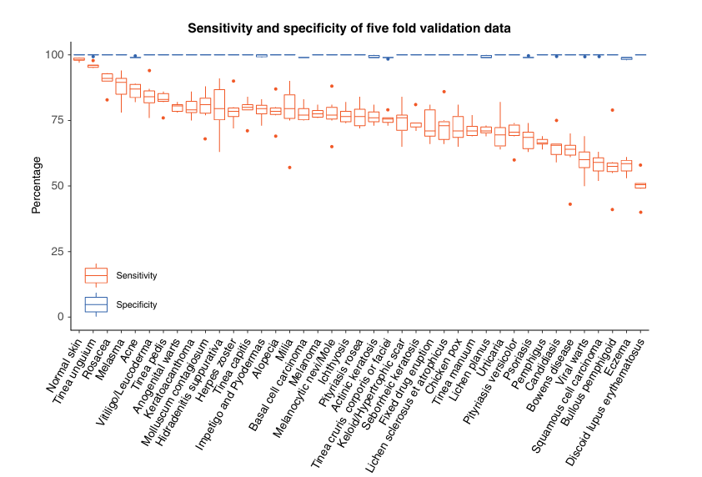

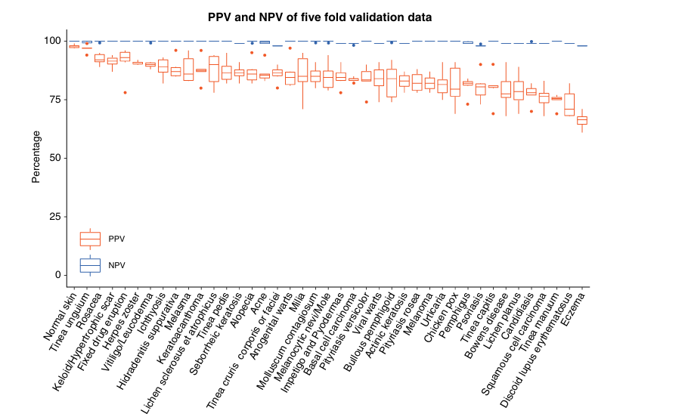

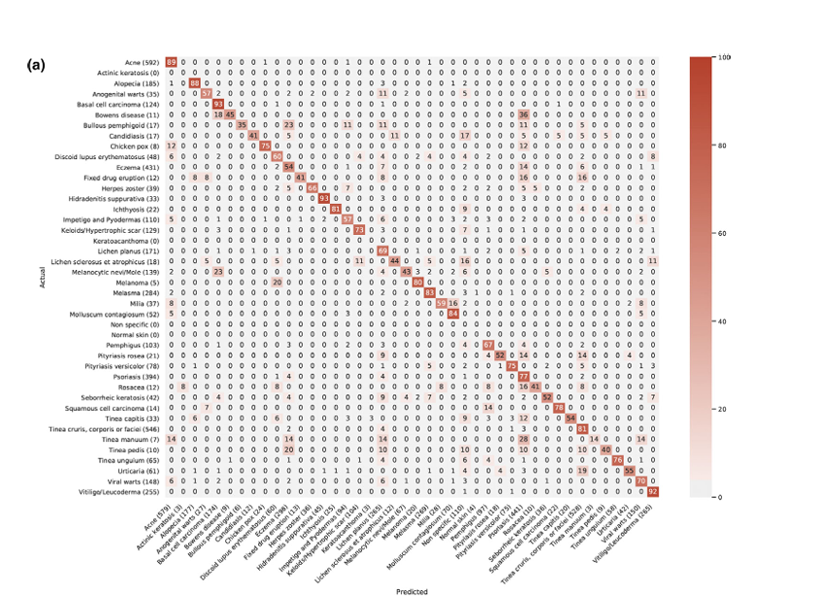

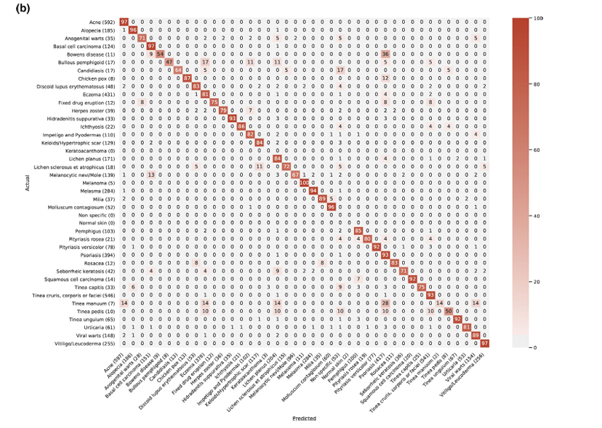

**Flowchart:**

**Step-by-Step Process:**

1. **Data Collection**:
   * **Dataset**: Download the HAM10000 dataset from Kaggle and GitHub. This dataset contains images of various skin conditions, including benign and malignant skin lesions.
   * **Preprocessing**: Resize, normalize, and augment the images to prepare them for training. Ensure all images are consistent in size and quality.
2. **Model Selection**:
   * **Base Models**: Select pre-trained models like MobileNetV2 or InceptionV3, which are lightweight and optimized for mobile devices.
   * **Custom Model**: If necessary, design a custom Convolutional Neural Network (CNN) model tailored to the specific needs of skin disease detection.
3. **Model Training**:
   * **Training Environment**: Set up a training environment using TensorFlow, ensuring GPU acceleration if possible.
   * **Training Process**: Train the selected model on the preprocessed dataset. Implement techniques like transfer learning to improve accuracy.
   * **Validation and Testing**: Split the dataset into training, validation, and testing sets. Evaluate the model's performance using metrics like accuracy, precision, recall, and F1-score.
4. **Model Optimization**:
   * **Quantization**: Convert the trained model to TensorFlow Lite format, applying techniques like quantization to reduce model size and improve inference speed.
   * **Testing on Mobile Devices**: Deploy the model on a mobile device for testing. Ensure it runs efficiently, with low latency and minimal resource consumption.
5. **Application Development**:
   * **Front-End Design**: Develop a user-friendly mobile application interface using Android Studio.
   * **Backend Integration**: Integrate the TensorFlow Lite model into the app, ensuring seamless communication between the front-end and the model.
   * **Real-Time Prediction**: Implement real-time image capture and processing within the app, allowing users to take photos and receive instant feedback on potential skin conditions.
6. **User Testing and Feedback**:
   * **Beta Testing**: Release the app to a group of beta testers, including dermatologists and general users, to gather feedback on usability and accuracy.
   * **Iteration**: Based on feedback, refine the model and app features to improve performance and user experience.
7. **Deployment and Maintenance**:
   * **Final Deployment**: Deploy the app on platforms like Google Play Store, making it available to the public.
   * **Continuous Monitoring**: Monitor the app's performance, release updates, and retrain the model periodically with new data to improve accuracy and adapt to new skin conditions.

**Flowchart: Experiment Workflow**

Below is the textual description of the flowchart:

1. **Start**
2. **Data Collection**
   * Download and preprocess HAM10000 dataset.
3. **Model Selection**
   * Choose pre-trained models (e.g., MobileNetV2, InceptionV3).
4. **Model Training**
   * Train model on preprocessed data.
   * Validate and test the model.
5. **Model Optimization**
   * Convert to TensorFlow Lite and optimize.
   * Test model on mobile devices.
6. **Application Development**
   * Develop front-end UI.
   * Integrate TensorFlow Lite model.
   * Implement real-time prediction.
7. **User Testing and Feedback**
   * Conduct beta testing.
   * Iterate based on feedback.

**Comparison of existing works and technology in mobile applications:**

|  |
| --- |
|  |
| | **Study/Technology** | **Year** | **Focus Area** | **Model/Algorithm** | **Key Features** | **Limitations** | | --- | --- | --- | --- | --- | --- | | **A Machine Learning-based Decision Support Mobile App** | 2020 | Dermatological Diseases Diagnosis | CNN (Convolutional Neural Network) | - Mobile-based decision support - User-friendly interface - Real-time feedback | - Limited to common dermatological diseases - Requires internet connection | | **Bacterial Skin and Soft Tissue Infections: A Review** | 2008 | Diagnosis and Treatment of Bacterial Skin Infections | N/A (Review Paper) | - Comprehensive review of bacterial skin infections - Treatment options | - Not focused on mobile applications - No machine learning implementation | | **Skin Cancer Detection Using Deep Learning—A Review** | 2023 | Skin Cancer Detection | Deep Learning (CNNs, RNNs) | - In-depth review of deep learning techniques - Focus on image processing for skin cancer | - Review-based study - No practical mobile application implementation | |

**Skeleton of the UI:**

